

**SMART DINE-IN SYSTEM**

**Made By:**

**Manas Chopra [16csu191]**

**Mansha Chandna [16csu196]**

**Mayank Jain [16csu198]**

**Mohit Kalra [16csu213]**

**Under the guidance of**

**Mrs. Mehak Khurana**

**TABLE OF CONTENTS**

1. Objective
2. Introduction
3. System Requirement
4. Methodology
5. System Architecture
6. Comparison and existing models
7. Commercialization possibility
8. Time estimation
9. Budget Estimation
10. Conclusion
11. References

**OBJECTIVE**

The objective of this project is to automate the restaurant system and increase the quality of service by designing a grid layout track for food serving trolleys (along the ceiling ), which delivers the food ordered to the customer to his table.

The project covers following areas related to smart dining system:

1. Shortest path calculated from kitchen to destination table
2. Avoids the risk of accidentally dropping of food.
3. Efficient use of restaurant space by using grid layout
4. Fast delivery
5. First order, first served: The one who places the order first gets the food first.

Key features of the project:

* Precise as compared to conventional methods.
* Implementation using IOT.
* Using the restaurant space efficiently.
* Installation of hardware along the ceiling, no customizations needed on the floor.
* Uses technology to order and pay for the food.

This idea of the project can be cater to fulfill the needs of medium/large restaurants.

**INTRODUCTION**

This project is a prototype for automating services at the restaurant, it is restricted within the restaurant premises. This project is useful for the customers, chefs and the administrator.

The purpose of this project is to increase the quality of service at restaurants by creating a grid layout track for the food trolleys that carry the customer`s orders.

A grid layout allows efficient use of the restaurant space, thereby optimizing the seating capacity as well as a faster delivery with variable number of trolleys.

Furthermore, it will help avoid long queues at the ordering/payment counters aided by an app provision. In addition, it avoids the risk of accidently dropping food.

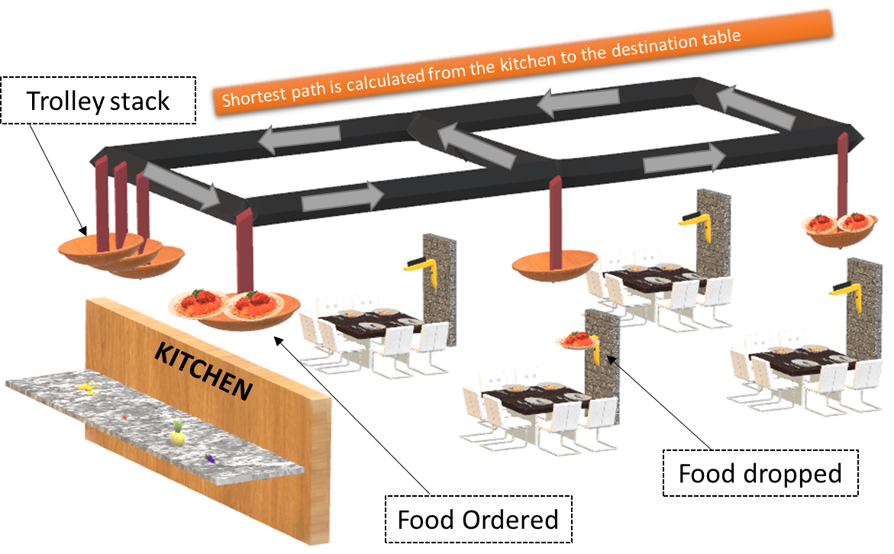

**SYSTEM REQUIREMENTS**

For proper implementation of system, we require the following gadgets:

* Arduino Nano and Arduino Mega
* SENSORS: weight, UV sensors,
* RFID readers and tags
* DC motors
* Stepper motors
* Bearings
* Wheels
* Linear Actuators
* Pneumatic grippers
* Wires
* Batteries
* MDF plywood board
* Trays
* Android app
* Bluetooth/ Wi-Fi module

**METHODOLOGY-**

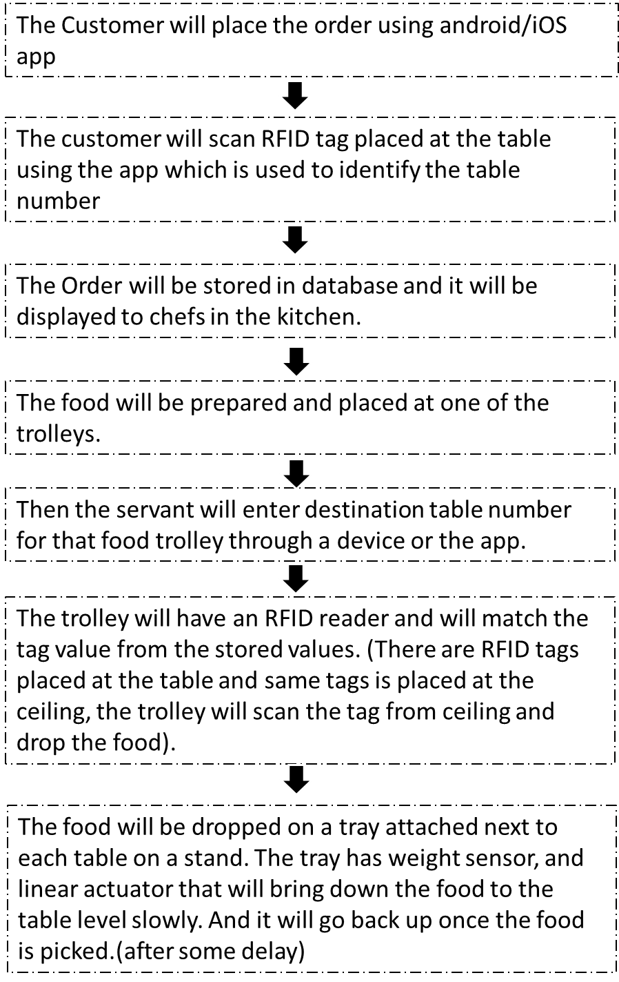

Need for such a system is:

1. To increase quality of service.
2. Easy way for managing customers at rush hours.
3. Using technology to order and pay for food in faster way.
4. Promoting ‘Make in India’.
5. Automatized system is more precise and better when compared to the traditional and conventional ways.
6. Reduces human labor.
7. Cost efficient system.

**SYSTEM ARCHITECTURE-**

* **OUTER VIEW OF THE SYSTEM**



* **GUI SHOWING THE CALCULATED SHORTEST PATH FROM KITCHEN TO DESTINATION TABLE –**

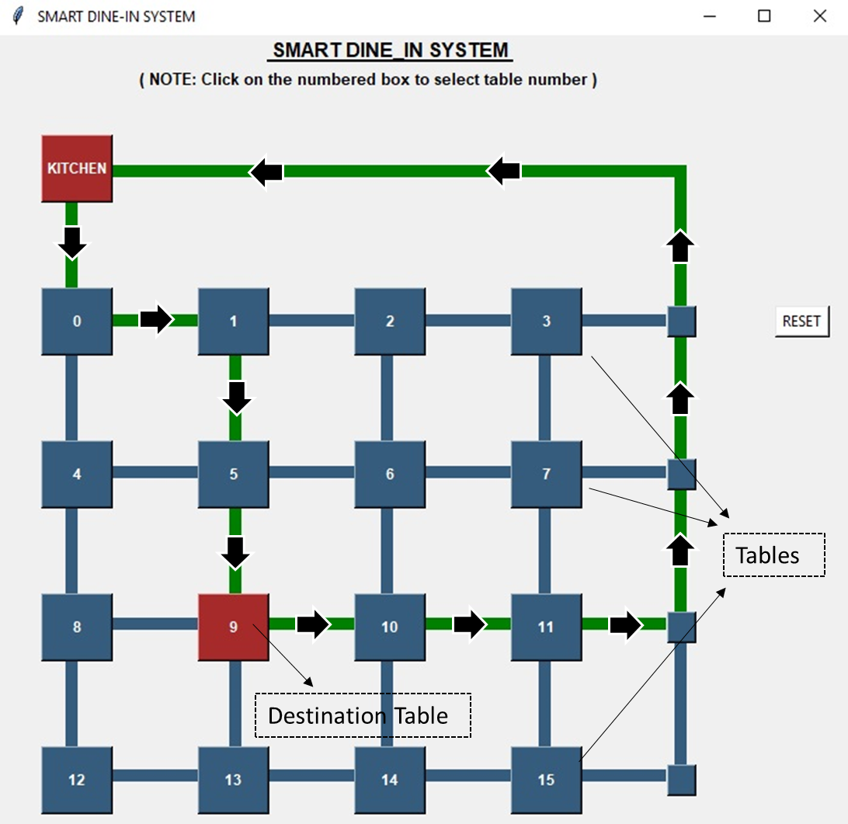

**COMPARISON AND EXISTING MODELS**

There are few similar existing models, but none of them is implemented in India.

There are mainly two type of models:

1. The trolleys move along one path only, and the tables are placed along the walls. Which is a major drawback for medium/ large restaurants as they have open space in them, which can`t be used with such a kind of model.
2. In the other type of model, the trolleys move in a spiral/ circular manner, which is placed in the center of a circular table and the trolleys deliver food using face recognition. Such model will not be successful in India because not all the seated members can interact with each other, only the adjacent members will be able to interact with each other.

Also, in this model, the seating capacity of the restaurant is reduced.

Whereas this project has a grid layout implementation, which overcomes all the issues like efficient use of open space, all the seated members can interact with each other.

In addition, the seating capacity of the restaurant will not be altered in order to install this system.

**COMMERCIALIZATION POSSIBILITY:**

Commercialization of this project is possible. The prototype will show the exact structure and working of the system with complete software and hardware implementation.

Such a technology is not installed in India, and it is quite useful in near future as medium/ large restaurants have a lot of rush and this model will help them to manage their work efficiently.

No need to manage a large number of servants, making the system cost effective and monitoring becomes simpler.

The number of trolleys are variable, they can be added or removed easily as per the requirement of the restaurant.

The system supports variable seating size tables. It is not necessary for the tables to be equidistant.

Also, there are no battery issues for running trolleys, we can lay copper sheets along the grid track, and the tyres of the trollies can be made up of carbon fiber, which will provide a continuous AC supply to the trolley without any wiring problem. (A battery will be used in the prototype, to power each trolley)

**TIME ESTIMATION-**

The project is estimated to be complete in 4-5 months (tentatively) and would require 4 people having software and hardware knowledge related to IOT as well as in making android app.

The project can be divided into sub-modules:

1. Making android app [partially complete]
2. Designing and connecting the Database
3. Making GUI to easily monitor and make changes to the database (Required by chefs to update the status of orders placed.)
4. Creating program to calculate shortest path from kitchen to destination table. [Done]
5. Designing of system hardware [Done]
6. Creating trolley
7. Creating the track and tables.
8. Arduino coding
9. Integrating all of the above.

|  |  |  |
| --- | --- | --- |
| **Activity** | **Type of activity** | **Duration (in months)** |
|  |  | **Start-Finish** |
| 1 | Making android app | 25th January - 15th February |
| 2 | Designing and connecting the database | 16th February - 16nd March |
| 3 | Making GUI to easily monitor and make changes to the database | 17th march - 31st march |
| 4 | Creating program to calculate shortest path from kitchen to destination table. | DONE |
| 5 | Designing of system hardware | DONE |
| 6 | Creating trolley | 1st April – 21st April |
| 7 | Creating the track and tables | 22nd April- 1st May |
| 8 | Arduino Coding | May |
| 9 | Integrating all modules | June-July |

**BUDGET REQUIREMENTS:**

We will design a prototype with 9 tables (3x3 grid) and 2 Trolleys.

The following equipment are required to construct this prototype.

|  |  |  |  |  |  |
| --- | --- | --- | --- | --- | --- |
| **Sr. No.** | **Capital Equipment** | **Qty** | **Justification for purchase** |  | **Total**  **(Rs.)** |
|  |  |  |  |  |  |
| **REQUIREMENTS FOR TROLLEY** | | | | | |
| 1 | Arduino Mega | 2 | More ports requires for 2 trolleys |  | 1500 |
| 2 | Wheels | 8 | 4 for each trolley |  | 1000 |
| 3 | DC motors | 8 | To power the tyres |  |
| 4 | Bearings | 8 | For axial motion of Wheels |  | 320 |
| 5 | Stepper motor | 8 | To control axial motion speed and degrees to rotate |  | 5200 |
| 6 | RFID reader and tags | 2 | 2 RFID readers for each trolley |  | 1400 |
| 7 | Extra tags |  | Total 18 tags required in the system |  | 1000 |
| 8 | UV sensors | 4 | 2 for each trolley (To avoid collision) |  | 320 |
| 9 | 9v Battery | 4 | Power supply for Arduino and DC motors |  | 80 |
| 10 | Pneumatic grippers | 2 | To hold the trays |  | 3200 |
| 11 | Bluetooth module | 2 | One for each trolley to send input for destination table. |  | 500 |
|  |  |  |  |  |  |
| **REQUIREMENTS FOR TRACK AND TABLES** | | | | | |
| 1 | Arduino Nano | 9 | One to support execution of linear actuator and weight sensor at each table |  | 2700 |
| 2 | Weight Sensors  +  HX711 Load cell amplifier module | 9 | To sense if food tray has been dropped on the actuator and bring tray down to table |  | 3420 |
| 3 | Linear Actuator (Rs. 2450)  +  Mounting Brackets for the linear actuator (Rs. 435) | 9 | To bring dropped food from trolley, slowly to the table level |  | 25965 |
| 4 | .MDF Plywood | 1 | For track and base of the prototype |  | 1100 |
| 5 | Miscellaneous charges |  |  |  | 5000 |
| **TOTAL** | | | | | **52705** |

**Extra Manpower Required:**

Need assistance from an expert to cut the exact dimensions of MDF Ply for grid track.

**CONCLUSION-**

The system is a full-fledged implementation of hardware and software for increasing the quality of service at restaurants.

It will help to avoid unnecessary waiting in queues for ordering and billing. Making payments will become faster and easier with security intact.

It will completely change the era of dine-in and it will be another step towards the prime minister`s concept of Digital India and in addition, it will promote Make in India.

**REFERENCES –**

* Mr. Pankaj Rakheja
* Mr. Surinder Kumar Sahini
* Google.com
* Robu.in